**Exercise: Playbooks - Discrete Plays**

1. Verify that your ansible installation is available by displaying the version of ansible while logged in as the 'user' user.

[test@tcox3 ~]$ ansible --version

ansible 1.9.2

  configured module search path = None

2. Run the ansible command that lists all of the hosts configured in your control server 'hosts' file for the system.

[test@tcox3 ~]$ ansible all --list-hosts

    tcox5.mylabserver.com

    localhost

    tcox4.mylabserver.com

3. Create a playbook, using the 'INCLUDE' concepts from the video:

- Uses SSH

- Logs in to the remote system as 'test' user

- Connects to ALL servers

- The playbook runs as 'sudo'

- Skip gathering remote facts

- Create a directory called 'plays'. Create a YAML file that runs a task to install one or more packages using the 'yum' module

- Include that file in the playbook so that the created YAML file in the 'plays' directory above runs in the 'tasks' section

- After the included tasks run, verify that the package is installed remotely using the 'raw' module, log the output to a file called 'pkgs.log' in remote /home/test

[test@tcox3 Playbooks]$ vim include.yml

[test@tcox3 Playbooks]$ cat include.yml

--- # FULL INCLUDE TASKS EXAMPLE

- hosts: apacheweb

  user: test

  sudo: yes

  connection: ssh

  gather_facts: no

  tasks:

    - include: plays/packages.yml

    - name: Verify the telnet package is installed

      raw: yum list installed | grep telnet > /home/test/pkgs.log

4. Run the playbook and display the results.

[test@tcox3 Playbooks]$ ansible-playbook include.yml

PLAY [apacheweb] **************************************************************

TASK: [Install the telnet client] *********************************************

ok: [tcox4.mylabserver.com]

TASK: [Install the Lynx web browser] ******************************************

changed: [tcox4.mylabserver.com]

TASK: [Verify the telnet package is installed] ********************************

ok: [tcox4.mylabserver.com]

PLAY RECAP ********************************************************************

tcox4.mylabserver.com      : ok=3    changed=1    unreachable=0    failed=0

LAB :

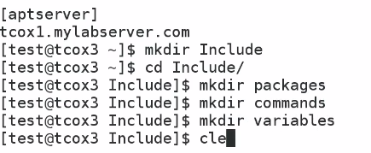

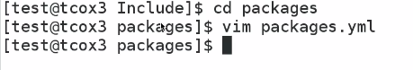

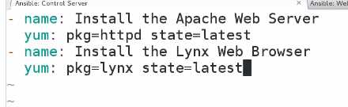

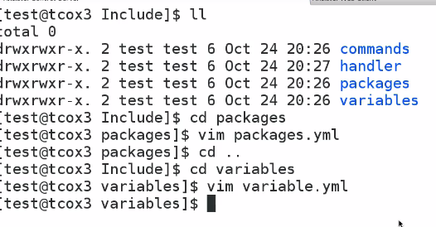

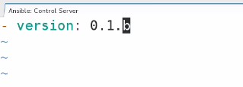

Remove the -

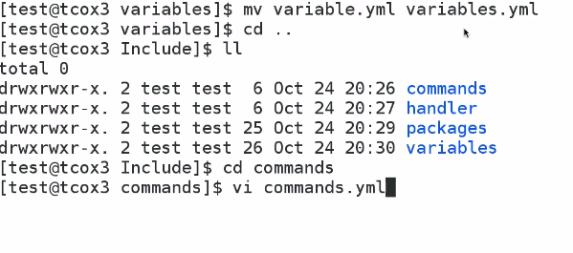

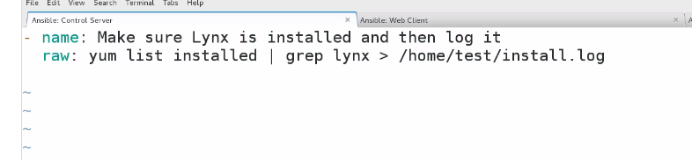

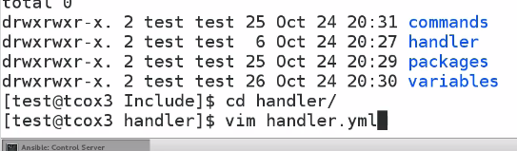

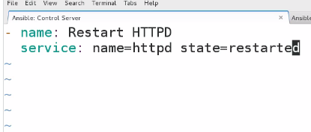

As we we are usinh handler we need to add notify in package

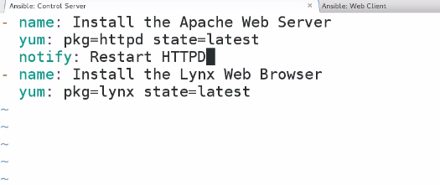

So final PLAYBOOK ..

